**Tutorial 15: Emitting Custom Events**

We need to display a way where we can hide and show the modal and not display the modal the moment we land on the page.

Make sure **Tutorial 14** is complete to be able to move on to this tutorial or clone the [vue3-firebase-course](https://github.com/younggrasshopperza/vue3-firebase-course) repository and go to branch called **Tutorial-14**.

**Step 1:** In the **App.vue** file, create a data property called showModal and set the value to false. Wrap the Modal component in a div and provide a condition that shcecks whether show modal is true. Underneath create a click even and attach a function called toggleModal. In the methods change the showModal value to the opposite value when the function is called.

Look at the example below (**Between** **line 3 to 7, line 22 and between line 26 to 28**):

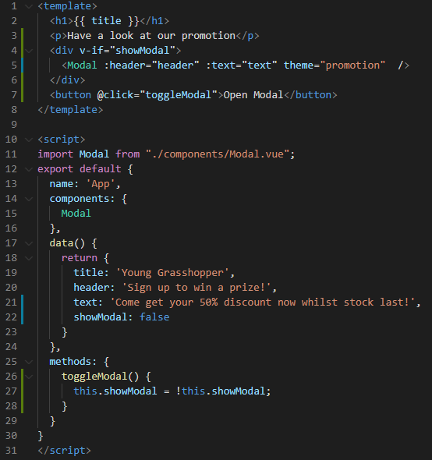

**Output:**

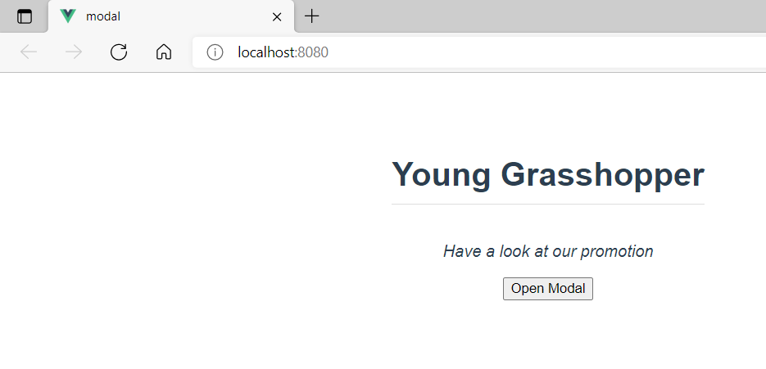

**Step 2:** In the **Modal.vue** file, create a click event that takes a function called closeModal, attached to the div with the class backdrop. Create the function in the methods section that has an emit that takes the value close.

Emit pushes the click event up to the parent component so that we are able to call another function in the parent component when an action takes place in the child component.

Look at the example below (**Between** **line 2 and between line 13 to 15**):

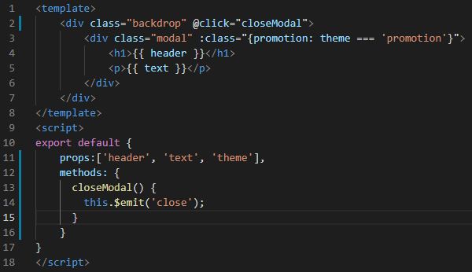

In the **App.vue** file, you can call the emit called close like click event inside the Modal component with function toggleModal.

Look at the example below (**Between** **line 5**):

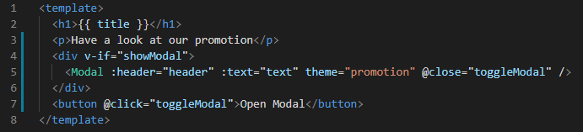

When the modal appears click on the background and watch the modal go away.

**You can view the code snippets from the** [**vue3-firebase-course**](https://github.com/younggrasshopperza/vue3-firebase-course) **repository under the Tutorial-15 branch.**